**ASSIGNMENT 1**

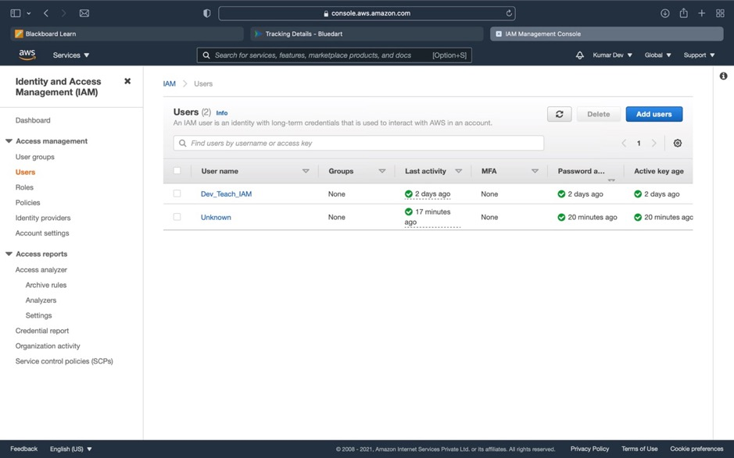

These are the Users that I have previously

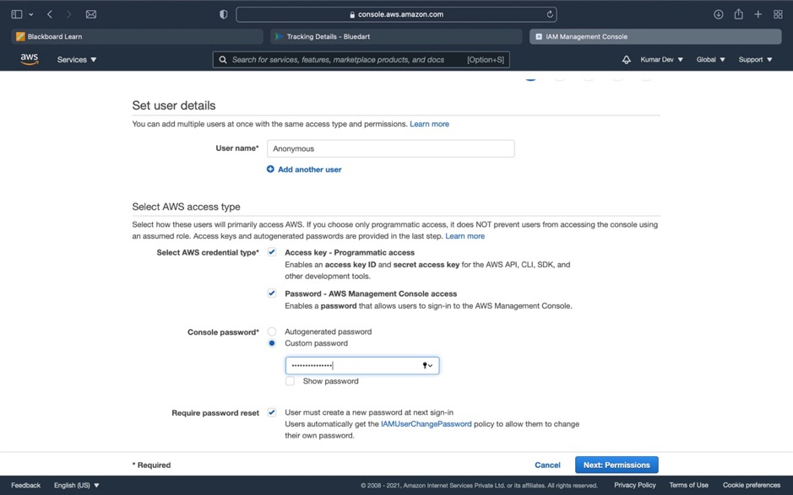

Setting User Details Name and Credentials type.

Setting Policies:

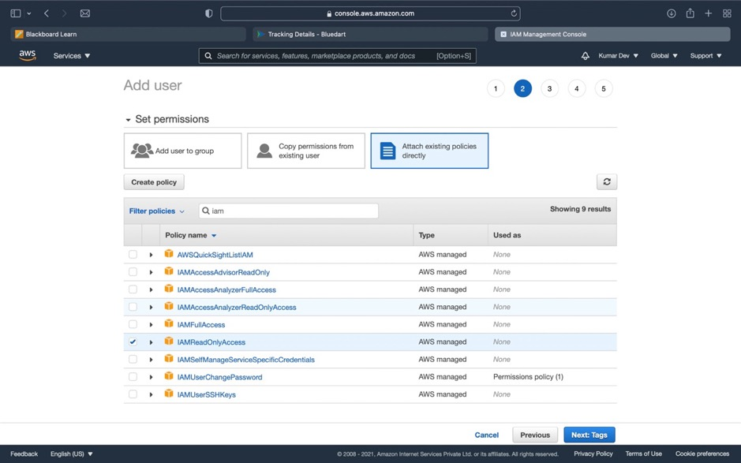

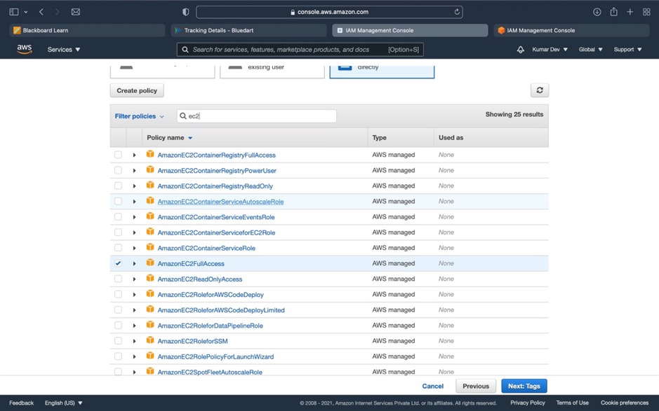

Setting Permission for the user that which services user can access

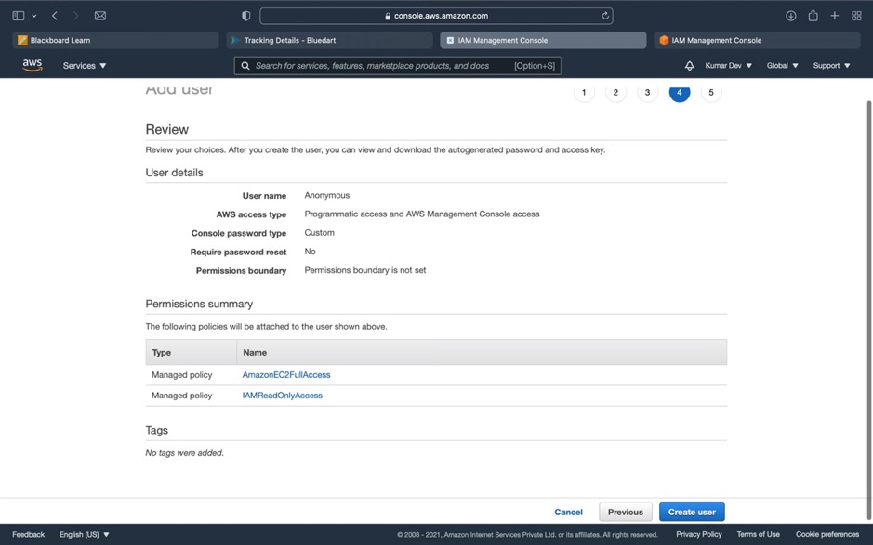

These are the User Details now we have to click on create user to create.

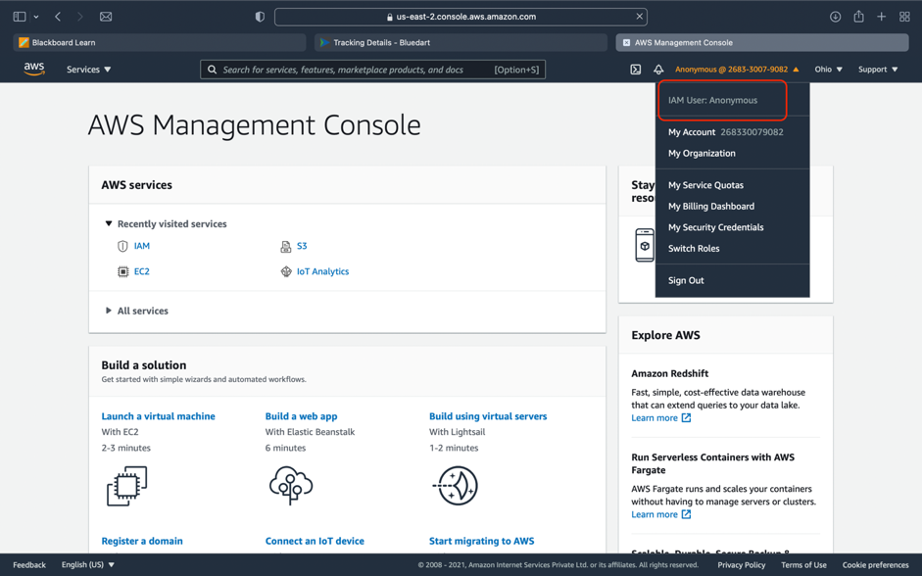

Here I was signed in as IAM user.

So let’s check what permission we give to IAM user and whether he will be able to access those services or not.

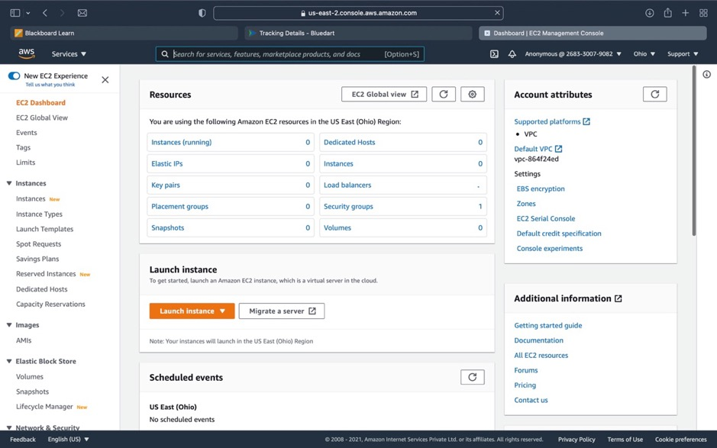

So IAM user be able to access EC2 Services because we gave permission for this.

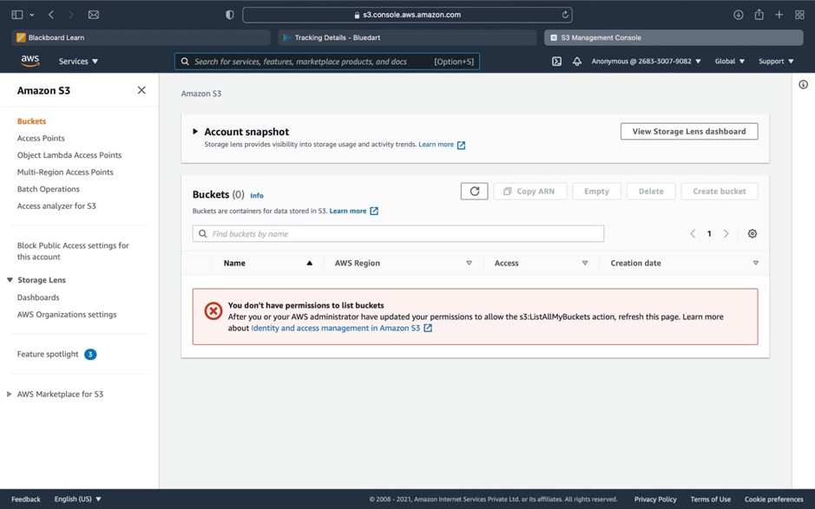

So here we are not able to access S3 Bucket Services because IAM user is not given access for this.